Mirror-Han- See the light of the long days without forgetting

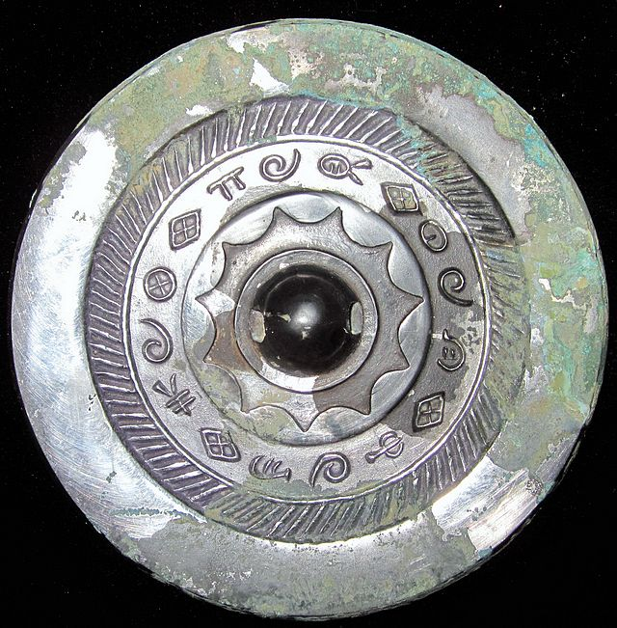

见日之光长毋相忘

See the light of the long days without forgetting

Ebay 1400 USD